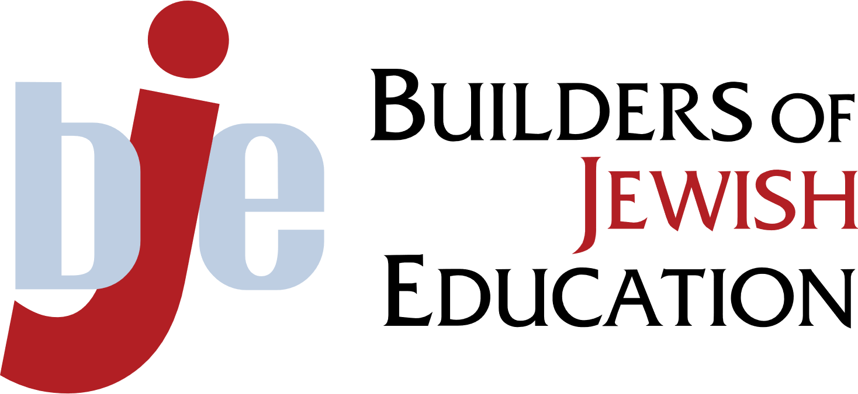

**Day School Leadership Retreat**

Artificial Intelligence: Exploring Possibilities



March 25, 2025

de Toledo High School

We are grateful for the support of….

**CONFERENCE SCHEDULE**

8:00am Registration, light breakfast

8:30am Welcome

Keynote Speaker: Malka Katzin

*AI, Education, and the Jewish Future: Embracing Innovation with Purpose*

9:30am Workshops - Session #1

10:45am Workshops - Session #2

12:00pm Lunch

1:00pm Workshops - Session #3

2:00pm End of Conference (Optional: team meetings)

**Workshops - Session #1 9:30am**

|  |  |  |
| --- | --- | --- |
| **Topic** | **Speaker** | **Location** |
| From Sage to Guide: Teaching in the AI-Enhanced Classroom | Dr. Sarah Rubison Levy | Auditorium |
| Generative AI, déjà vu all over again. Jump Right In! | Dr. Josh Sharfman | 206 |
| *Chochmat HaBinah*: AI Wisdom in Jewish Education | Orly Lavi Travish | 282 |
| I Finally Found More Time in My Day: Time-Saving AI Basics for Administrators | Lauren Dolinka | Farber 302 |
| Leveraging AI in School Administration & Operations | Rabbi Yitzchak Feiglin | Rita’s Room North |

**Workshops - Session #2 10:45am**

|  |  |  |
| --- | --- | --- |
| **Topic** | **Speaker** | **Location** |
| AI Policy Playbook: Crafting Ethical and Effective Guidelines for Your School | Dr. Sarah Rubison Levy | Auditorium |
| Generative AI, déjà vu all over again. Jump Right In! | Dr. Josh Sharfman | 206 |
| *Chochmat HaBinah*: AI Wisdom in Jewish Education | Orly Lavi Travish | 282 |
| I Finally Found More Time in My Day: Time-Saving AI Basics for Administrators | Lauren Dolinka | Farber 302 |

**Workshops - Session #3 1:00pm**

|  |  |  |
| --- | --- | --- |
| **Topic** | **Speaker** | **Location** |
| AI and Assessment | Dr. Sarah Rubison Levy | Auditorium |
| Generative AI, déjà vu all over again. Jump Right In! | Dr. Josh Sharfman | 206 |
| *Chochmat HaBinah*: AI Wisdom in Jewish Education | Orly Lavi Travish | 282 |
| Leveraging AI in School Administration & Operations | Rabbi Yitzchak Feiglin | Rita’s Room North |

**2:00pm OPTIONAL:**

**Team Meetings (Dr. Sarah Rubison Levy facilitating)**

**Location: Auditorium**

**Workshop Descriptions**

**Dr. Sarah Rubison Levy: From Sage to Guide: Teaching in the AI-Enhanced Classroom**

As AI reshapes education, what does it mean to be a teacher today? This session will consider the role of the teacher and explore how educators can integrate AI into their curriculum while emphasizing critical thinking, digital literacy, and Jewish values. Gain practical strategies for designing meaningful learning experiences that prepare students for an AI-driven world.

**Dr. Sarah Rubison Levy: AI Policy Playbook: Crafting Ethical and Effective Guidelines for Your School**

How should schools approach AI use in a way that fosters innovation while upholding ethical and educational principles? In this session, school leaders will walk through key considerations for developing responsible AI policies that align with their mission, values, and long-term educational goals.

**Dr. Sarah Rubison Levy: AI and Assessment**

Examine how AI reshapes assessment, from personalized learning analytics to project-based approaches. Discuss how Jewish day schools can maintain rigorous standards while embracing AI tools.

**Dr. Josh Sharfman: Generative AI, déjà vu all over again. Jump Right In! (Repeated 3 times)**

We will lead off with a brief history of Generative AI and gain an understanding of how Generative AI works. Participants will engage in the playing the Game of NIM and use that experience to inform how AI systems learn. Equipped with that knowledge, we will conduct some group exercises to hone critical thinking skills to evaluate and assess the correctness of what is generated in response to natural language prompts.

With this background and experience we will explore two specific use cases in detail and discover how to engineer meaningful prompts to assist Jewish Day School teachers and administrators accelerate both daunting and mundane tasks using Generative AI so their time and focus can be directed to what they can uniquely contribute.

The first use case will be leveraging the tools to facilitate progress report and report card writing. The second area of inquiry will be partnering with the AI tools to help create grade level, course subject, and class comportment sixty-section set inductions to help transition between subjects and/or different classroom learning environments.

**Orly Lavi Travish:  "*Chochmat HaBinah*: AI Wisdom in Jewish Education" (Repeated 3 times)**

We stand at a pivotal moment in educational history. Artificial Intelligence is rapidly transforming every facet of our lives, and Jewish education must embrace AI to enhance learning while preserving its core values.  This interactive workshop explores the innovative ways Artificial Intelligence can enhance Jewish education. Through hands-on activities and collaborative learning, participants will discover how to integrate AI tools into Hebrew language instruction, Jewish studies, and heritage education.  Learn how to develop engaging educational experiences that seamlessly blend technology with Jewish values and traditions.

Exploring the responsible implementation of AI in education, we will delve into a crucial discussion on ethics and values. Our focus will be on how Jewish wisdom can guide us towards utilizing technology to enhance, rather than detract from, our educational mission.

This workshop is designed for Jewish educational leaders, including school principals, education directors, and Hebrew department heads, who are looking to innovate and lead their institutions into the future without compromising Jewish tradition. Participants will gain practical tools, strategic insights, and actionable plans that they can implement immediately in their educational settings.

**Lauren Dolinka: I Finally Found More Time in My Day: Time-Saving AI Basics for Administrators (Repeated 2 times)**

Overwhelmed by administrative tasks? AI can help you work smarter, not harder! In this interactive workshop, administrators will explore practical, time-saving AI strategies to boost efficiency and streamline daily responsibilities. Learn how to use AI for drafting communications, crafting meeting agendas, writing letters of recommendation, streamlining curriculum planning, providing observation feedback, and more. Walk away with actionable insights and easy-to-implement techniques that free up valuable time—so you can focus on what truly matters.

**Rabbi Yitzchak Feiglin: The Art of the Prompt: Leveraging AI in School Administration & Operations (Repeated 2 times)**

Artificial Intelligence is transforming the way organizations operate, and schools are no exception. This workshop will explore how AI-driven services can be leveraged to improve efficiency, streamline workflows, and reduce the manual workload in school administration.

We will take a practical, hands-on look at real-world applications of AI in the back office, demonstrating how these tools can assist with everyday administrative tasks, financial management, admissions, development, and strategic decision-making. Whether automating routine communications or data organization, participants will see AI in action in real time.

As AI technology continues to evolve, its potential to revolutionize school operations grows exponentially. This session will guide participants through a range of use cases, starting with simple automation and progressing to more complex, high-impact applications. Whether you’re new to AI or looking for advanced ways to integrate it into your school’s operations, this workshop will provide valuable insights and practical takeaways to help you make the most of this rapidly advancing technology

**Presenter Bios**

**Malka Katzin - Keynote**

Malka Katzin is a change agent, a collaborative team player, a digital enabler, a GenAI leader and a proud working mom. She currently leads Digital Workplace, Knowledge Tech & Product Enablement globally for Boston Consulting Group. She drives strategy, delivery and enablement for the collaboration, productivity, knowledge and GenAI tools that power our consulting team. She also leads centers of expertise in the areas of change management, user experience and agile ways of working. Her career has ranged from strategy consulting to healthcare marketing to HR to knowledge management & digital workplace. In all of her business roles, Malka has consistently and successfully focused on change management, delivering impact, fostering networks & collaboration and driving innovation. She is known for successfully delivering large-scale transformations, driving operational excellence and balancing focus between technology, processes and culture. In her personal life, Malka is a wife to Josh and mom to Sonya (junior at Shalhevet), Leo (freshman at Shalhevet) and Josie (6th grader at Hillel.) She has served on Jewish school boards in Hong Kong, Oakland and LA, and is currently in her second year as Board Chair at Harkham Hillel Hebrew Academy. Read more about Malka: <https://www.linkedin.com/in/malka-katzin-7440174/>

**Dr. Josh Sharfman**

Last July, Dr. Josh Sharfman retired from his career in high technology to pursue his passion for teaching full-time. Josh attended the Hillel Hebrew Academy back in the day when it met in the lower level of Beth Jacob Congregation. Upon returning from Yeshivat Netiv Meir in Jerusalem, he completed high school at Rambam, the precursor to YULA. Josh’s four children also attended Jewish Day Schools in Los Angeles. Josh is presently in his tenth year of teaching computer science at Shalhevet High School and previously served as a part-time adjunct professor of engineering at USC for 19 years. Sharfman has worked with the California Association of REALTORS® for the prior forty-one years: as a consultant; as an outside board member of the Association’s Real Estate Business Services subsidiary; and for the last 20 years as the Association’s Chief Technology and Innovation Officer. Prior to joining C.A.R. full-time, Josh led product development for a variety of privately held and public companies, including LRN, Digital Lava, ParcPlace-Digitalk, Inc., Dassault Systemes USA, CADAM Inc., and Hughes Aircraft. Josh holds six system and method patents with additional applications in the pipeline. He provides expert testimony for software patent and copyright infringement matters.

**Dr. Sarah Rubinson Levy**

**Dr. Sarah** Rubinson Levy empowers excellence and innovation in education, partnering with schools and organizations to achieve their highest potential. As a thought partner, strategic project manager, and content expert, she helps leaders create effective, joyful, and future-ready learning environments—always keeping students at the center. With over 20 years of experience, Sarah holds a doctorate and multiple certifications in day school education, Jewish leadership, and executive coaching. She is also a recognized expert in AI and education, having earned certifications in Elements of AI and Responsible AI and delivered a TEDx talk on the topic. Her work focuses on progressive, student-centered education, AI integration, professional development, and strategic systems design. A proud Colorado native, she lives in Denver with her four kids, dog, beta fish, and leopard gecko—and is always happy to share ski recommendations. Sarah’s new book, *Crafting the Future: Navigating AI and Jewish Education*, will be published soon. Learn more at Sarah at: <https://www.sarahrubinsoncc.com/>

**Orly Lavi Travish**

Orly Lavi Travish, an educational entrepreneur and founder of 972EDUCATION INC, specializes in innovative Hebrew language and Israeli culture education. As an expert in second language acquisition, she pioneers AI and Project-Based Language Learning (PBLL) methodologies. She also consults and mentors schools and teachers on modern teaching methods and tech integration. Orly is a trailblazer in integrating AI into Hebrew language curricula, organizing the first international conferences on AI applications for Hebrew teachers. She actively trains teachers in AI tools, manages a 2,000+ member Facebook community for language educators, and co-hosts a Hebrew podcast on second language teaching. Her innovative approach and commitment to technology-driven education establish her as a leader in modernizing Hebrew language instruction. Orly sees herself as a change agent, committed to elevating the status of the Hebrew language and to professionalizing the field of Hebrew education nationally and internationally.

**Lauren Dolinka**

Lauren Dolinka is the Lower School Director at Sinai Akiba Academy and has dedicated her career to Jewish education. She is deeply committed to the mission of raising children to be self-aware, thoughtful, and responsible community members, and she believes in nurturing these traits through a Jewish lens. Before joining Sinai Akiba in 2021, Lauren spent eight years at San Diego Jewish Academy, teaching across all grade levels in both General and Judaic Studies, leading faculty development, and coordinating Jewish programming. She is also an instructor of Math Methods for the DeLeT (Day School Leadership through Teaching) program at Hebrew Union College and has served as a Clinical Educator and Alumni Network Steering Committee member. Lauren earned her B.A. in English Literature with a minor in Mathematics from UC Santa Barbara, followed by an M.A. in Education from Bar Ilan University while teaching in Israel. She is a DeLeT alum with a certificate in Jewish Day School Education and a Multiple Subject Teaching Credential. Most recently, she completed the School Leadership Academy at USC, earning her Preliminary Administrative Services Credential. A Los Angeles native, Lauren is an active member of the Jewish community, along with her husband, Mike, and their two children, Lev and Aviv.

**Rabbi Yitzchak Feiglin**

Rabbi Feiglin, originally from Melbourne, Australia, came to the United States in 2004 to further his studies in esteemed Yeshivah and Kollel institutions across the U.S. and Israel. After settling in Valley Village, he has spent the past decade serving as the Director of Operations and IT at Valley Torah High School. In this role, he has been instrumental in leveraging emerging technologies to support the school’s rapid growth, optimizing operational efficiency, and enhancing stakeholder engagement. A forward-thinking advocate for artificial intelligence, Rabbi Feiglin has integrated AI-driven solutions into various administrative workflows, continuously refining these implementations as the technology evolves. Beyond his professional endeavors, he is a devoted husband and father of five. The Feiglin family enjoys embarking on road trips to explore the diverse and breathtaking landscapes of the United States. Deeply committed to community service, Rabbi Feiglin is actively involved in several Jewish organizations in Los Angeles, contributing to the enrichment and support of the local Jewish community.